<https://www.youtube.com/watch?v=3FNYvj2U0HM&list=PLLKT__MCUeixqHJ1TRqrHsEd6_EdEvo47>

**Ethical Hacking in 15 Hours - 2023 Edition - Learn to Hack! (Part 1)**

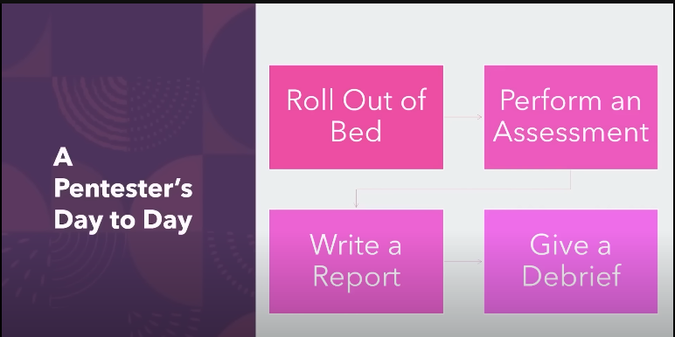

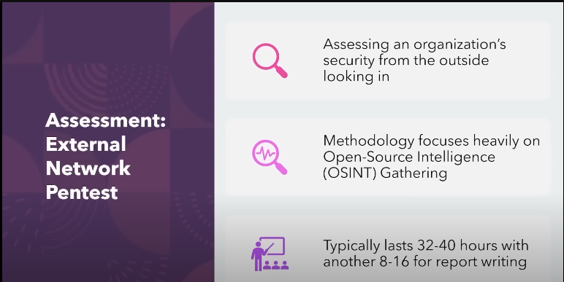

External pentest ( common )

Internal pentest

Open-Source Intelligence (OSINT)

SSH server

Active directory

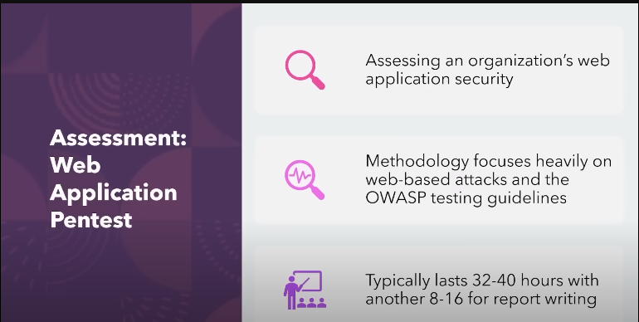

OWASP 🡪 open web application security project

Their testing guidelines web application + mobile

They has how to test /prevent/defend

OWASP top 10 attacks on web application

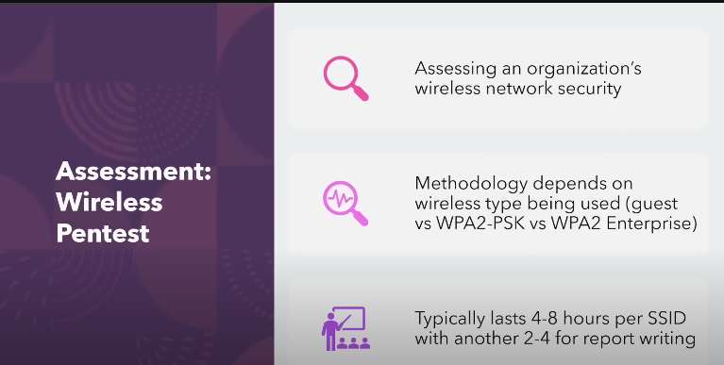

Wireless pentest straightforward

Wireless adaptor

SSID

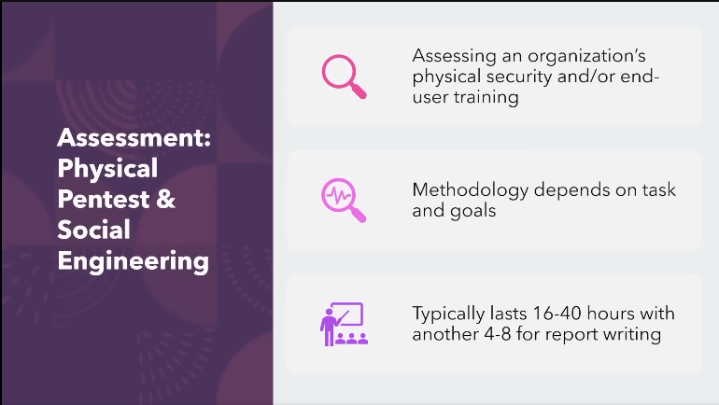

Very fun engagement

Pure social engineering

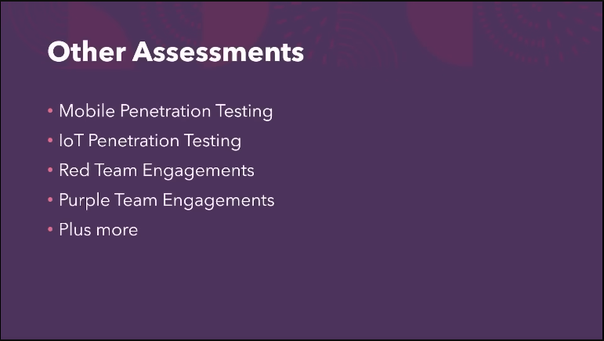

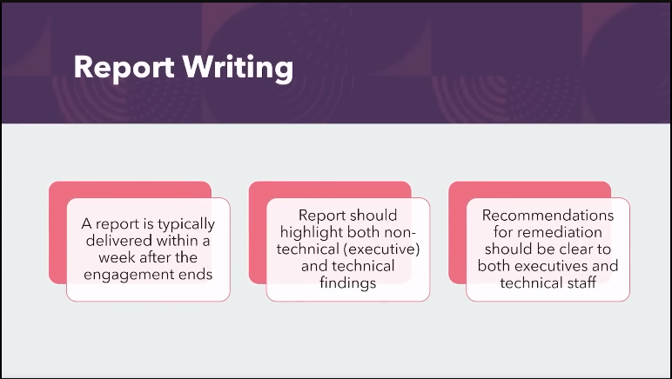

Keed to get better at report writing

25:27